Champions for Learning – Finance Committee Meeting Agenda and Notes
Meeting Time: Monday, May 12, 2025
Join Zoom Meeting
https://zoom.us/j/93959050812
- Opening Remarks – Roger Lipitz
- Approval of the Minutes – Finance Committee Meeting – March 11, 2025
- Review April 30, 2025, Financial Statements with Projected Year End Actuals
- Endowment 3rd Quarter 2025 Review and Spending Percentage Approval for FY 2025
- Florida Prepaid Purchase FY 2025
- Cash Strategy Review (approval of signers) and $1M Bequest Gift
- Budget Presentation FY 2026

- Review April 30, 2025 Financial Statements and Projected Actuals for FY 2025

The CFL Management Accounts April 30, 2025, excel document presents the financial statements with 6 tabs at the bottom of the excel sheet.

The CFL Projection Schedules for FY25 and FY26 excel document show the projected actuals versus budget for fiscal year 2025. Revenues are projected at $3.4M and expenses of $3.3M resulting in a surplus of $140,000k (after the endowment release) for the ending fiscal year. These figures do not include Pre-paid usage, Disaster Relief, endowment contributions and non-budget relieving RTC. (see table below for budget comparison).
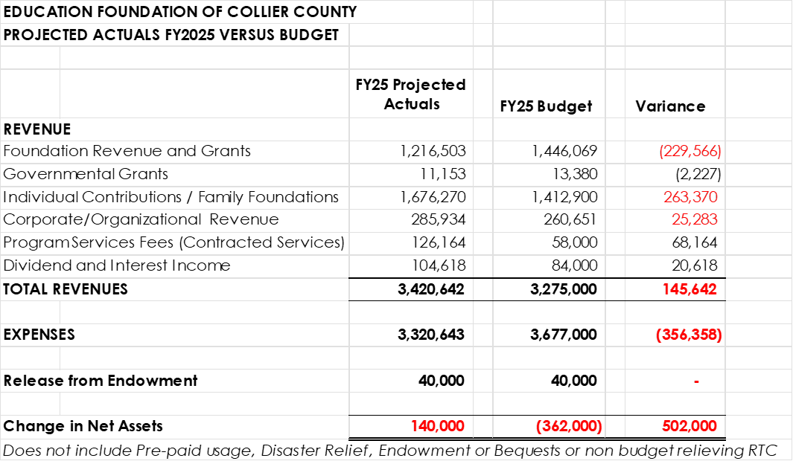

- Endowment 3rd Quarter 2025 Review and Spending Percentage Approval for FY 2025
The approved Endowment Program Policy included a spending policy in which funds will be expended to support the annual operating and program budgets. We are proposing a spending rate this year of 4% equal to an estimated $50,000 for this current fiscal year ending June 30, 2025 (based on current value of $1,280,000 minus the $2.5M contribution) and $175,000 as part of our annual budget preparation for FY 2026 (based on a total value of $4.5M including both the $2.5M contribution and the $1M bequest).

- Florida Prepaid Purchase FY 2025
Kristin Carlson, Director of Student Programs, will be reviewing the proposed purchase for our Prepaid Scholarships for the fiscal year 2025. Please see the document 24-25 Florida Prepaid Purchase detail for the final amounts for review and presentation to the Board of Directors.

- Cash Strategy Review (approval of signers) and $1M Bequest Gift

- Proposed Budget FY2026

The CFL Projection Schedules for FY25 and FY26 excel document (tab 2) shows the proposed budget for FY2026.

The proposed budget includes total revenues of $3.5M, an increase of $104k over this year’s projected income. The assumptions for each category of income are presented below:

- Foundation income is projected at $1.3M, an increase of $86k over this year’s projected actuals.
- Individual donor income is projected at $1.8M, an increase of $143k over this year’s revenue.
- Government Grants and Corporations/Organizations revenues are staying flat.
- We received over $126k in funding through multiple Resiliency grants from the Consortium this fiscal year. We closed these grants in 2025 and are not anticipating additional program service grants.
- Special Event Revenue includes two events for FY 2026 (see tab 4) : Night of Champions and Golden Apple. NOC is projected to have total gross revenues of $1.1M, flat with this year’s event revenues. The projected net income is $814k, a decrease of $23k over this year’s net income due to increasing costs. The Golden Apple is projected to have gross revenues of $55k, a slight increase of with this year’s revenue. We have budgeted for a dinner/gala event similar to previous years so the income and expenses have increased to reflect this event.

Total projected expenses for FY26 are $3.7M, which includes an increase of $379k in expenses from this year’s projected expenses but almost flat to FY25 originally budgeted expenses.

The largest single component of CFL’s annual budget, representing almost 55% of total expenditures, is staff costs. The FY26 budget includes a staffing level of 17 FTE in comparison to an average of 15 FTE for this past fiscal year 2025. An annual Cost of Living Allowance (COLA) of 4% is included in this proposed budget. Professional Services include outsourcing a Human Resource consultant (40k), IT consultants ($45K) and $35k for additional strategic planning consultants.

The projected ending change in net assets for FY25 is a flat budget with the release of the 4% endowment funds.

Department and project details, including monthly figures of the proposed fiscal year 2025 budget are presented in this excel document and the following document titled CFL TOTAL FY 2026 Proposed Budget – Organizational Budget.

