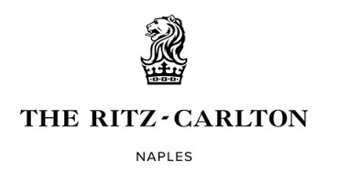

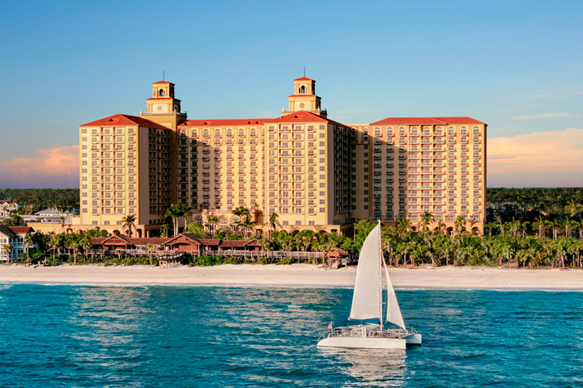

Night of Champions Gala

Menu Tasting
Friday, December 12th, 2025

COLD HORS D’OEUVRES

Tuna Tartar Unagi Sauce, Pickled Ginger, Seaweed, Sesame Seed Cone (G)
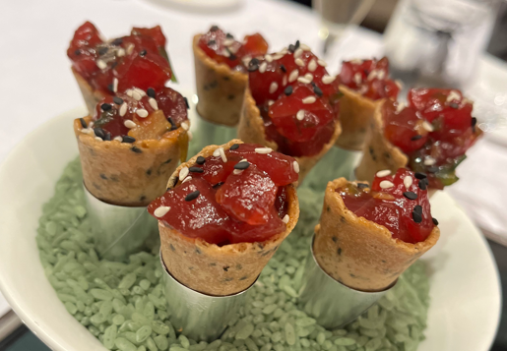

Goat Cheese Tuscan Toast Pepper Jam, Baby Pepper, Kalamata Powder (D) (G)(Veg)
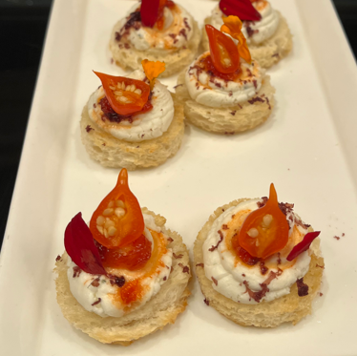

HOT HORS D’OEUVRES

Chicken Ragu Mini Bouchee (D) (G)
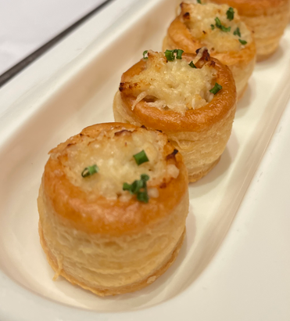
SALAD
Compressed Watermelon Marinated Feta, Frisee, Citrus Caviar, Peruvian Peppers,
Pomegranate Oil and Dressing (D) (Veg)
Notes: Add focaccia crouton

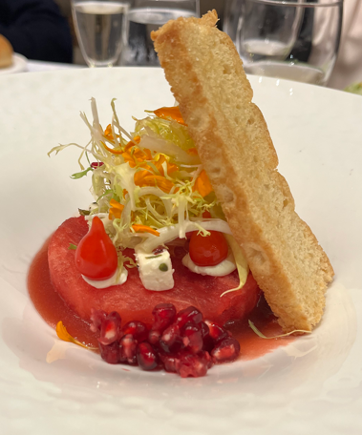

ENTREE
Braised Short Rib, Silken Honeynut Squash Emulsion, Confit Potatoes, Green Asparagus,
Heirloom Baby Carrot, Port Wine Jus (G)
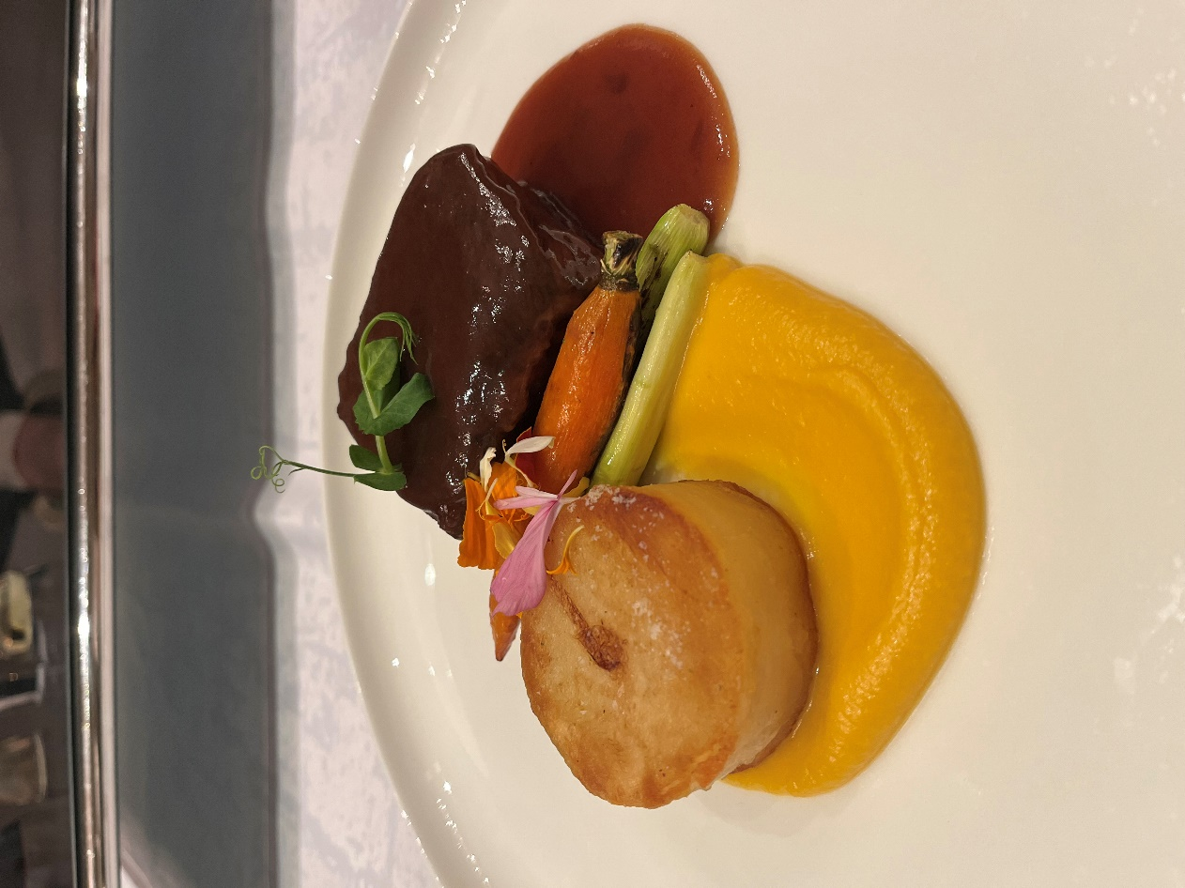

DESSERT

Mai Tai, Pineapple Chutney, White Chocolate Coconut Mousse, Lime Crumble, Pineapple Passion Rum Cremeux (D, G)
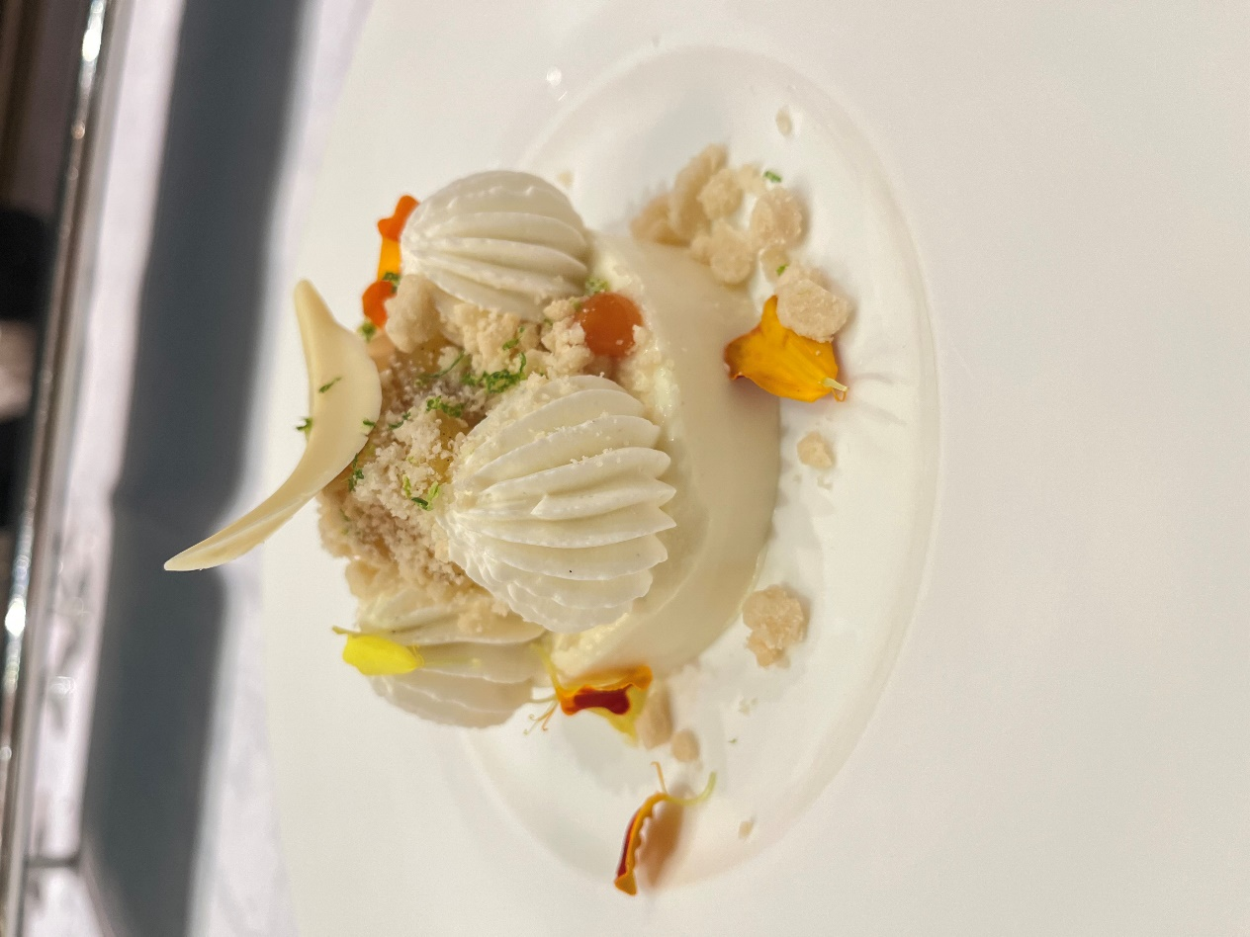

WINES

Martin Ray Chardonnay
Martin Ray Cabernet Sauvignon

